2020 GOCI – Southern Cross Region Toowoomba Rally
Planning is now well underway for the 2020 Toowoomba Rally. We have secured the venue for accommodation (feel free to book your cabin at the discounted rates). In case you need it you can contact the caravan park at http://www.big4toowoombagchp.com.au/ - please mention the Graham Club for your discounted rates.
We can confirm the rallies will alternate between long & short days with plenty of time to explore Toowoomba & surrounds at your own pace.
As per tradition there will be a welcome BBQ the 1st night. We will also allow ample time to catch up with your fellow ralliers for a debrief at the end of each day should you wish.
We are looking at maybe another BBQ dinner and a possible movie night to help relax after a day of rallying.
There will be the traditional farewell dinner - theme TBC.
We can also tell you that you may see a historic building or 3 on our travels.
There will be a designated day for the ladies – we know that sometimes cars just aren’t your thing so hopefully we can make a day you all enjoy.
We will be showing off Queensland’s railway history including a disused rail tunnel built in the early 1900’s.
We will be exploring Queensland’s horse drawn history.
You will experience country driving at its best.
We will be showing off our rally base Toowoomba & why it is called the Garden City.
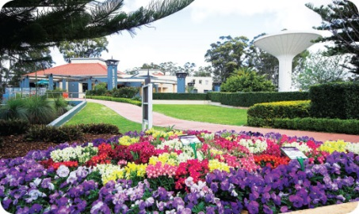
And there will be horsepower in different forms.
Could this be a hint as to some of the horsepower you may come across in your travels?
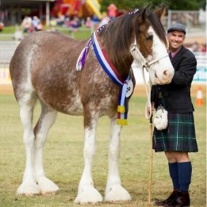 I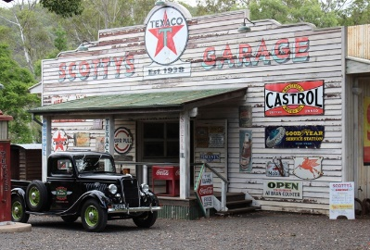
Don’t forget there is the Facebook page to help stay updated with what’s happening. Please feel free to invite a fellow Graham owner to the page & the rally. We would love to see you all here.
As a possible addition to the actual rally dates we are thinking about organizing a couple of extra days in Brisbane, 2 hours east of our rally base Toowoomba. We are taking expressions of interest for the extra few days – if we can get enough interest we will organize something. If you would like to participate can you please let us know?
If you have any questions or issues please do not hesitate to contact Craig & Janelle on crajan1@bigpond.com or 0418 743 943
